USER INTERFACE DESIGN EXPERIMENT-5

NAME : DURAIMADHAN M M ROLL NO:240701131

Conduct task analysis for an app and document user flows using Lucidchart

User Flow for a Civic Issue Reporter & Tracker System Start → Open Web App → Login/Register → User Dashboard → Click Report Issue → Enter Issue Details → Submit Issue →
Data Validation → Confirmation Message → Track Issue Status → Receive Resolution Notification → End

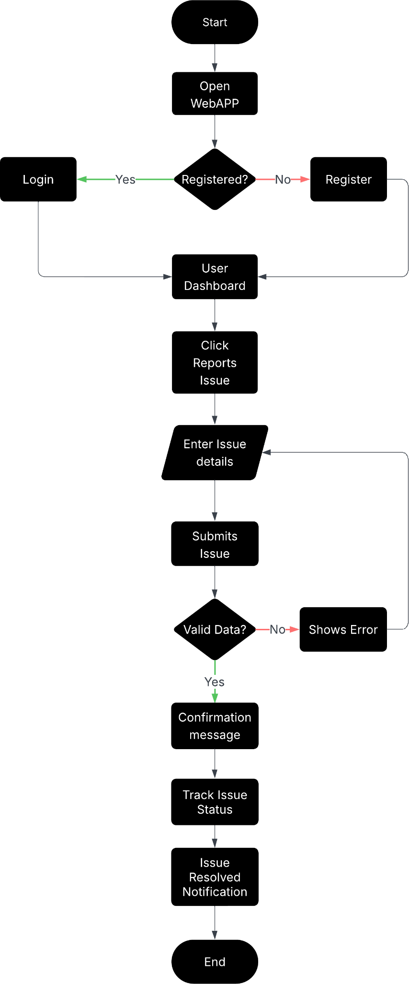

Step 1: Start
- The user opens the Civic Issue Reporter web application.

Step 2: Login or Register
- If the user already has an account, they log in.
- If not, they register and then log in.

Step 3: User Dashboard
- After logging in, the user is directed to the dashboard where they can view reported issues or report a new issue.

Step 4: Report Issue
- The user clicks the “Report Issue” option to submit a civic problem.

Step 5: Enter Issue Details
- The user enters details such as issue description, location, and uploads supporting images.

Step 6: Submit Issue
- The user submits the issue report.

Step 7: Data Validation
- The system checks whether the entered details are valid and complete.
- If the data is invalid, an error message is shown.

Step 8: Confirmation Message

- If the data is valid, the system displays a confirmation message through the feedback and in his notification.

Step 9: Track Issue Status
- The user can monitor the progress of the reported issue through the dashboard.

Step 10: Issue Resolution Notification
- Once the issue is resolved, the user receives a notification.

Prototype for user flow:

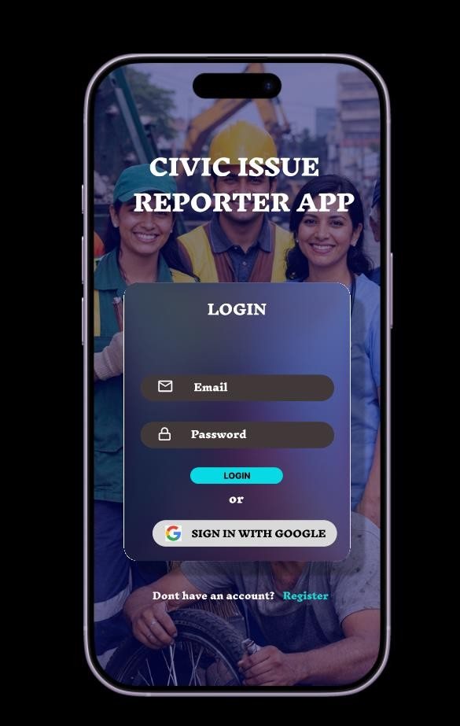

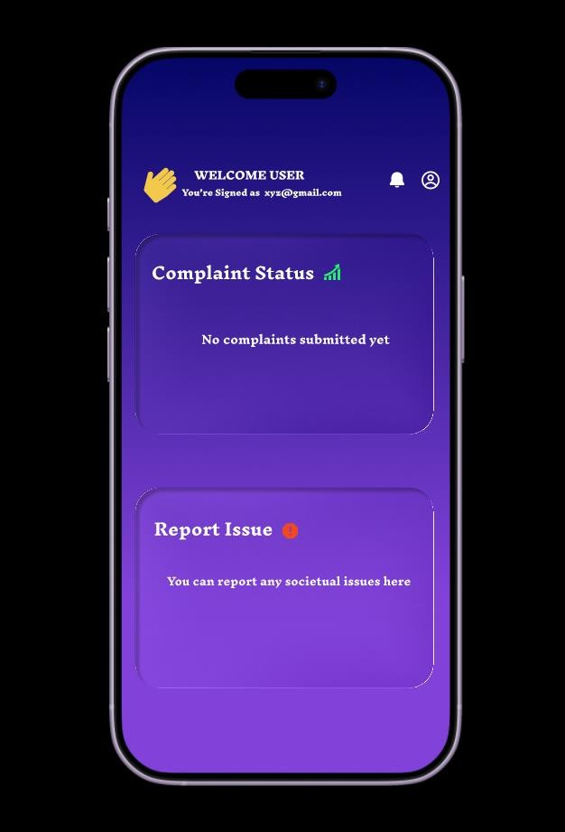

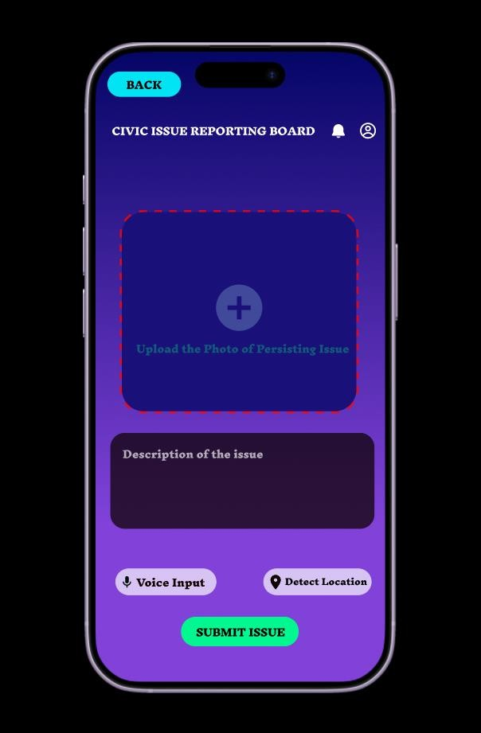

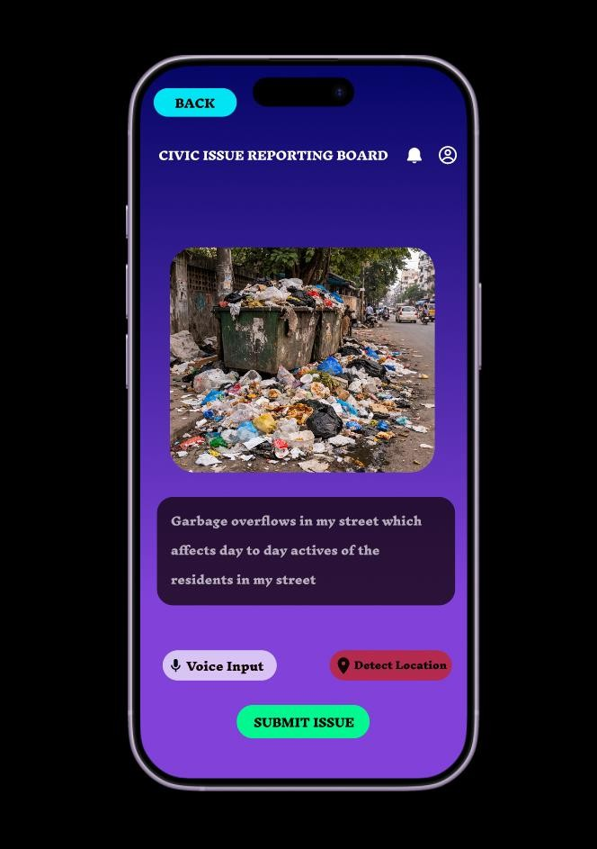

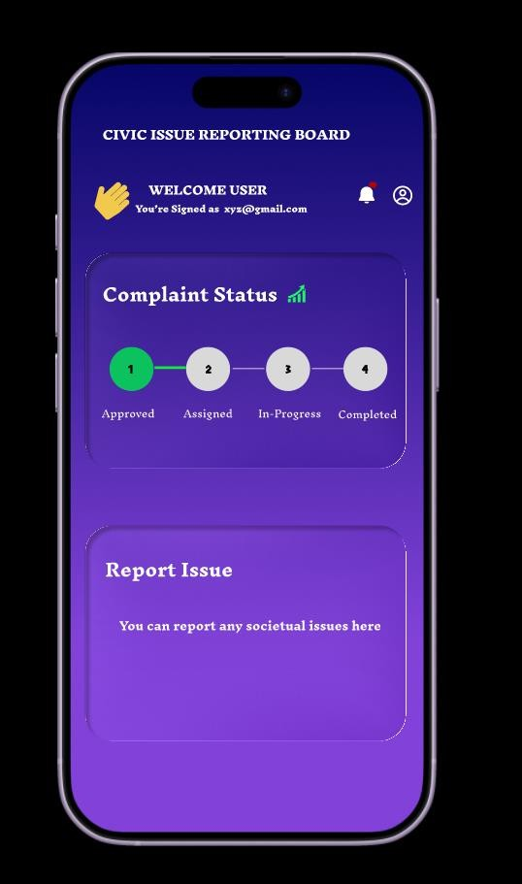

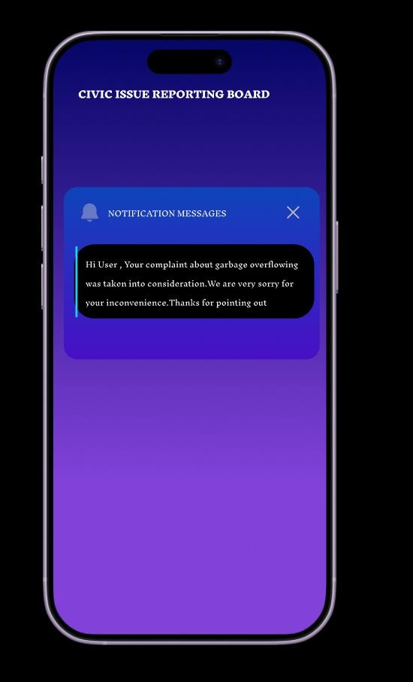

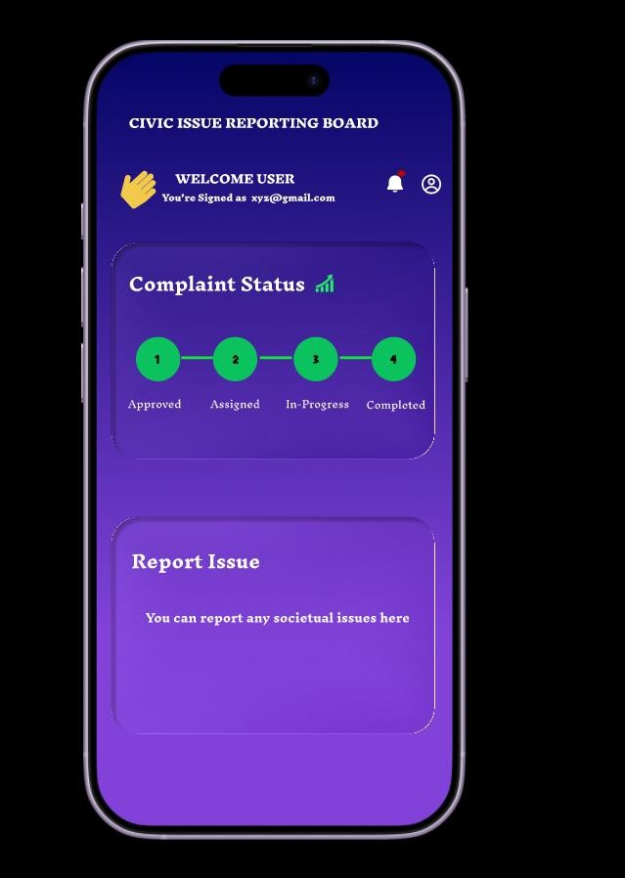

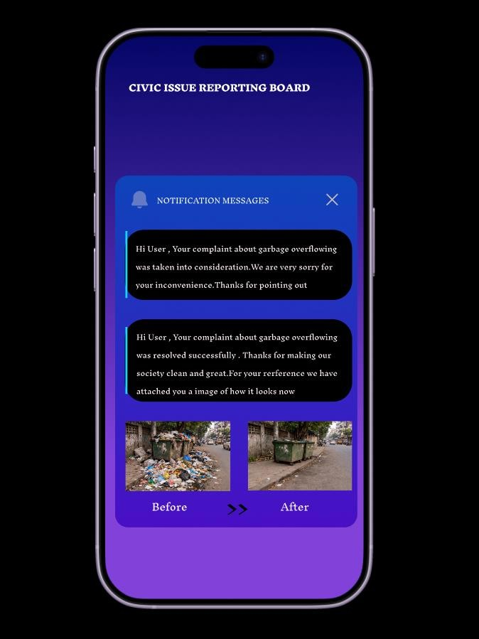

Prototype link :
https://www.figma.com/proto/PWkjLOuqwpKqaEfrwefWPn/Untitled?node- id=24-257&t=Hn2k33p1airkmaUu-0&scaling=scale-down&content- scaling=fixed&page-id=0%3A1&starting-point-node-id=1%3A2

